
SRM Institute of Science and Technology
Mode of Exam
OFFLINE
College of Engineering and Technology
School of Computing
DEPARTMENT OF COMPUTING TECHNOLOGIES
SRM Nagar, Kattankulathur – 603203, Chengalpattu District, Tamilnadu
Academic Year: 2023-2024 (ODD) Batch 1 – SET A
Test: CLAT-3 Date: 9/11/2023 Course Code & Title:18CSE458T/Wireless and Mobile Communication Duration: 1Hr 40 Mins
Year & Sem: VII Max. Marks: 50

Course Articulation Matrix:
CO/PO | PO1 | PO2 | PO3 | PO4 | PO5 | PO6 | PO7 | PO8 | PO9 | PO10 | PO11 | PO12 | PSO1 | PSO2 | PSO3
CO1 | 3 | 2 | - | - | - | - | - | - | - | - | - | - | - | - | -
CO2 | 2 | - | - | - | - | - | - | - | - | - | - | - | - | - | -
CO3 | 2 | - | - | - | - | - | - | - | - | - | - | - | - | - | 2
CO4 | 3 | - | 1 | - | - | - | - | - | - | - | - | - | - | - | -
CO5 | 3 | 1 | 2 | - | - | - | - | - | - | - | - | - | - | - | -

Part – A
(10 x 1 = 10 Marks)
Instructions: Answer all
Q. No | Question | Marks | BL | CO | PO | PI Code
1 | IPv6 does not use _________ type of address.  a) broadcast  b) multicast  c) anycast  d) unicast | 1 | 1 | 4 | 1 | 1.6.1
2 | What is the basic function of the snooping TCP?  - Flow control  - Congestion control  - To buffer the data that is in proximity to the mobile host for enabling fast local retransmission if the pocket loss is the case  - All of the above | 1 | 1 | 4 | 1 | 1.6.1
3 | WAP enhances ___ property?  - Wireless specification interoperability  - Wireless Side interoperability  - Wireless specification Infraction  - All the above | 1 | 1 | 4 | 1 | 1.6.1
4 | In which of the layer of OSI, WDP protocol stack of WAP works?  - Application layer  - Session layer  - Security layer  d) Transport layer | 1 | 1 | 4 | 1 | 1.6.1
5 | Which of the following is the function of session layer?  - Suspension  - Reconnection  - Speed connection  - All the above | 1 | 1 | 4 | 1 | 1.6.1
6 | Which of the following technology uses wireless communication mode to exchange data or transfer data between several mobiles in the short-range?  - Bluetooth technology  - Ad hoc computing  - Mobile computing  - None of the mentioned | 1 | 1 | 5 | 1 | 1.6.1
7 | What is the maximum signaling rate if the Operates in the 5 GHz frequency range of the IEEE 802.11a standard?  - 11 Mbps  - 1 Gbps  - 22Mbps  - 54 Mbps | 1 | 1 | 5 | 1 | 1.6.1
8 | Which multiple access technique is used by IEEE802.11 standard for wireless LAN?  - CDMA  - CSMA/CA  - ALOHA  - TDMA | 1 | 1 | 5 | 1 | 1.6.1
9 | In AODV routing algorithm for MANETs, the route is discovered at time  A. only when the network is established  B. in middle of the transmission  C. when there is a need for route by the host  D. All the above | 1 | 1 | 5 | 1 | 1.6.1
10 | How many components does the RFID system consists of?  - One  - Two  - Three  - Four | 1 | 1 | 5 | 1 | 1.6.1
Part B
(4 X 5 = 20 Marks)
11 | Illustrate the advantages and disadvantages of Snooping TCP | 2 | 1 | 4 | 1 | 1.6.1
12 | Discuss the Wireless Application Protocol in detail with neat diagram | 2 | 2 | 4 | 1 | 1.6.1
13 | Summarize the Characteristics of MANET Routing Protocol in detail | 2 | 2 | 5 | 1 | 1.6.1
14 | Describe different standards of Wi-Fi in detail | 2 | 2 | 5 | 1 | 1.6.1
Part – C
( 2 x 10 =20 Marks)
Instructions: Answer any one
15 a.  b. | Discuss in detail about Wireless Application Protocol with neat architecture diagram.  (or)  Summarize Wireless Datagram Protocol and Wireless Session Protocol in detail. | 10 | 2 | 4 | 1 | 1.6.1
16 a.  b. | Describe in detail about Bluetooth Technology with neat architecture diagram.  (or)  Explain in types of RFID tags with advantage and disadvantages with neat diagram. | 10 | 2 | 5 | 1 | 1.6.1

Course Outcome (CO) and Bloom’s level (BL) Coverage in Questions
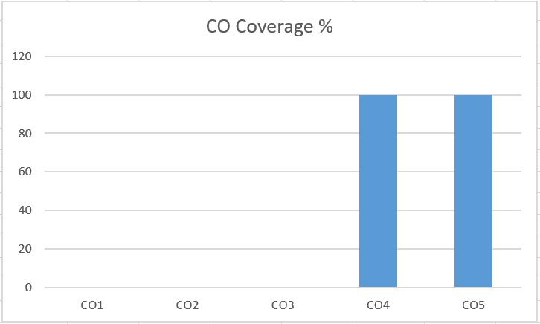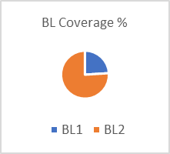

Approved by the Audit Professor/Course Coordinator

